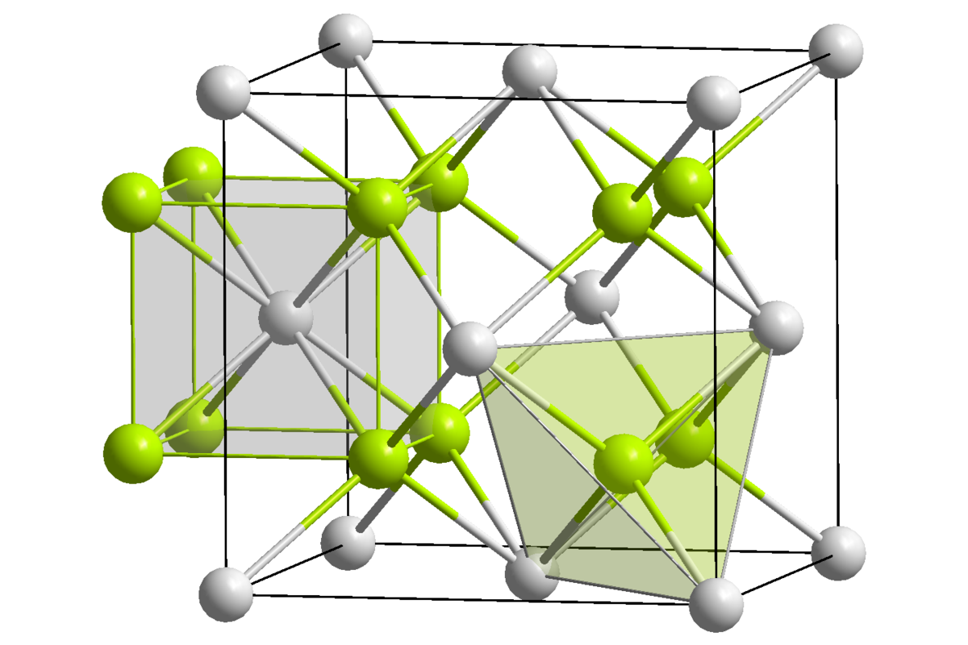

Chemistry Introduction to Chrystallography and Mineral structure.
Chrystallography is a division of Mineralogy that studies crystals and their geometric structures. Even a non-collector can appreciate the beautiful symmetry of minerals. To think that such crystals come from the ground “as is” is surprising to many as well as appreciated and sought after by rockhounds and hobbyists.
At one time the word crystal referred only to quartz, but has taken on a broader definition which includes all minerals with well expressed geometric shapes. Chrystallography studies a crystals geometric, physical, and chemical traits.
Mr. Stracener’s chemistry class will work in collaborative teams, researching one of the assigned crystals commonly found in the earth (Calcite, Flourite, Halite, Galena, Azurite, Gypsum, Forsterite, Corundum). The students will then submit a typed report and will also present to the class through google slides, a presentation about their mineral.
A third part of the PBL will involve the use of Tinkercad or a tool similar (such as thingiverse.com) in which students will create a 3D drawing of their mineral then using .SLT’s they will link the drawing to printers to produce a 3D model for class display.
This PBL will help students understand and link atomic structure to not just minerals, but all elements and compounds making up our world as we know it.
